

Demandware LINK Cartridge Integration Guide

Shopping Cart Abandonment Integration Guide

Contents

Summary 4

Component Overview 5

Functional Overview 5

Shopping Cart Abandonment 5

Activity Tracking 5

Click / Conversion Tracking 5

Scheduled Jobs 5

Newsletter Subscription 5

Modal Acquisition 5

Use Cases 5

Click & Conversion Tracking 5

Cart Abandonment Tracking 5

Browse Activity Tracking 6

Order History Synchronization 6

Email Newsletter Subscriptions 6

Modal Acquisition 6

Customer / Product Synchronization 6

Limitations, Constraints 6

Compatibility 6

Privacy, Payment 7

Implementation Guide 8

Setup 8

Configuration 8

Import custom objects / preferences 8

Custom site preferences 8

Scheduled jobs 9

Pipeline integration 10

Basket Preferences 13

Custom Code 14

External Interfaces 16

Testing 16

Operations, Maintenance 17

Data Storage 17

Availability 17

Support 17

User Guide 18

Roles, Responsibilities 18

Business Manager 18

Storefront Functionality 21

Known Issues 22

Release History 23

# Summary

Listrak’s Demandware Cartridge provides marketers with fully integrated ecommerce email solutions that drive revenue and customer lifetime value. By combining Listrak solutions with the features of Demandware, you are able to: recover abandoned carts with automated remarketing campaigns triggered upon abandonment, acquire more subscribers with modal acquisition, re-engage shoppers and customers with behavioral email campaigns, synchronize customers with your email list, and track customers browsing activity. The cartridge creates a connection between your Demandware store and Listrak to bring together customer behavior and order history to create targeted, data-driven email marketing to acquire new customers and sell more to existing customers.

A Listrak account is required prior to integration of the cartridge. This cartridge extends the functionality of a Demandware storefront by synchronizing data points to a Listrak account. This data is used to deploy email marketing campaigns such as: shopping cart abandonment, post purchase emails, targeted customer segments and more.

This cartridge also provides additional acquisition strategies to build your email marketing list. It will synchronize subscriptions to ensure your Listrak account is always updated with new additions. All subscriber removals will occur through the Listrak removal links embedded in emails.

The cartridge integration process involves several steps including:

* **Import custom objects** – to store data and settings
* **Import custom preferences** – to store configuration values
* **Incorporate pipeline components** – to tie into shopping events like adding to the cart and completing an order
* **Schedule job creation** – to send failed requests to Listrak and export order/catalog data

# Component Overview

## Functional Overview

### Shopping Cart Abandonment

As shoppers add items to their cart, a session is created and tracked by the Listrak cartridge. If the customer does not complete a purchase before leaving the site, the session will be marked as an abandoned cart. If an email address was attached to the shopping cart, Listrak will trigger a cart abandonment email series.

### Activity Tracking

As shoppers browse your store and look at products, the Listrak cartridge will log this activity and store it for marketing campaigns. JavaScript generated on your site by the cartridge will capture events to send to a Listrak endpoint so that no information is stored within your Demandware instance.

### Click / Conversion Tracking

When a visitor arrives at the storefront as a result of a click on an email sent from Listrak, a cookie is set for that session. If an order is completed within 30 days, the originating message is credited with the conversion revenue.

### Scheduled Jobs

Data is sent to Listrak on a continuous basis by scheduled jobs. Order history is exported regularly and sent to Listrak along with any other failed data requests. Customer and product information is exported to file and uploaded to Listrak daily using the Demandware FTP client.

### Newsletter Subscription

The Listrak cartridge enables merchants to push data to Listrak as customers complete forms to subscribe to a newsletter. These form elements are configured as custom objects through the BM and added as hidden fields to any existing form.

### Modal Acquisition

Functionality is included to display a modal popup to request customers to sign up to an email marketing list. The popup configuration is controlled within the Listrak application but code is inserted into pages by the cartridge to ensure the popup can appear anywhere.

## Use Cases

### Click & Conversion Tracking

Upon receiving an email sent from Listrak, a subscriber clicks on a link to the Demandware storefront. The cartridge will identify this click and set a session cookie for that shopper. The shopper adds items to their cart and continues to complete their purchase. The cartridge will assign the tracking cookie to their order. As order history is exported and uploaded to Listrak this session identifier is included allowing reporting to attribute the order back to the original message.

### Cart Abandonment Tracking

Once a shopper adds an item to their shopping cart, the cartridge will assign them a unique session ID. As the shopper travels through the site, this session is updated with activity. Once they decide to checkout and enter their email address during checkout, the session is associated with that email. If they decide to leave the checkout process, once the session reaches an inactivity threshold, it is identified as an abandoned cart. After abandonment, Listrak will trigger a series of emails to recover the shopper.

### Browse Activity Tracking

The Listrak cartridge will capture any shopper activity on your site, including products browsed. This information will be available for marketing campaigns through recommended products in emails and on your website. Browsing activity can also trigger an abandonment campaign based on recently viewed products.

### Order History Synchronization

In order for merchants to better understand buying habits of their customers, all orders placed in a Demandware storefront will be sent to Listrak on a continual basis through an export and FTP upload process.

Once the order history job runs for the first time, it will export up to 30 days of order data to upload to Listrak. Subsequent runs will only upload orders modified since the last export. It is recommended that new customers work with their Listrak project manager to upload order information that is older than 30 days.

### Email Newsletter Subscriptions

Demandware merchants will create custom email signup objects for each subscription form on their site. Once a hidden form field is included in the HTML template, and a Listrak pipeline is included in the form processing pipeline, any visitor submitting their email address will be sent to Listrak to be added to the designated email list potentially triggering a welcome series of emails.

### Modal Acquisition

If a modal acquisition popup is defined for a merchant, a visitor will see the signup form in a popup window where appropriate. Once they enter their email address and submit the form, the data is sent to Listrak, again potentially triggering a welcome series of emails.

### Customer / Product Synchronization

Every day, a scheduled job will send customer and product catalog information to Listrak. This information can be used to dynamically populate messages with personal and relevant information.

Once the Customer Synchronization job runs for the first time, it will export up to 30 days of customer data to upload to Listrak. Subsequent runs will only upload customers modified since the last export. It is recommended that new customers work with their Listrak project manager to upload order information that is older than 30 days.

## Limitations, Constraints

This cartridge requires the usage of an outbound FTP connection from the Demandware storefront. A support ticket may be required to open this method of communication. Instructions for submitting a support ticket can be found here:

<https://xchange.demandware.com/docs/DOC-2692>

## Compatibility

The Listrak cartridge was developed and tested on Demandware 12.2, compatibility mode 10.6.

## Privacy, Payment

No credit card data is stored or transmitted by this cartridge. Some customer information will be transferred including: email address, first and last name.

# Implementation Guide

## Setup

To import the cartridge into your store, within UX Studio select **File** -> **Import…** and choose **Existing Projects into Workspace** and click “Next” Find the *int_listrak* folder on your computer and complete the import process.

Once the cartridge is imported, you must assign Listrak to the cartridges within your storefront settings. In the Business Manager (BM) navigate to **Administration** -> **Sites** -> **Manage Sites** and select your site. Under the settings tab, add “:int_listrak” to the existing **Cartridges** and click “Apply.”

You must also assign the cartridge to the Business Manager for the scheduled jobs to be available to run. On the same page listing your sites, a separate area to manage the Business Manager Site will be below. Click the link to manage the **Business Manager** site. In the input for cartridges, add “:int_listrak” to the input and click “Apply.”

## Configuration

### Import custom objects / preferences

To import custom objects and preferences used by the Listrak cartridges, login to the BM and navigate to **Administration** -> **Site Development** -> **Import & Export** and click the “Upload” button. Find *int_listrak_metadata.xml* on your computer and upload the file. Once the upload is complete, click “Back” and then click the “Import” button underneath the Meta Data section. Select the Listrak settings file and click “Next” to validate the file. Once validated, click the “Import” button to finish the process.

### Custom site preferences

These preferences configure the way a Demandware storefront communicates with Listrak. To properly link your Demandware account to your Listrak account, you must enter the Listrak Merchant Tracking ID below:

* **Listrak Merchant Tracking ID** - <<MERCHANT_ID>>

If you are utilizing the Listrak Shopping Cart Abandonment and/or Activity Tracking Service, you must enable these modules by checking the following fields:

* **Enable Shopping cart Abandonment**
* **Enable Activity Tracking Service**

It is recommended that you configure your Listrak cartridge to perform Product, Customer and Order data synchronizations. To do so, you must check the following fields and enter your Listrak FTP user name and password:

* **Enable Product Sync**
* **Enable Customer Sync**
* **Enable Order Sync**
* **Listrak FTP User Name** *(required if Data Sync is enabled)* - <<FTP_USERNAME>>
* **Listrak FTP Password** *(required if Data Sync is enabled)* - <<FTP_PASSWORD>>
* **Top Level Category Index**
* **Product Sub-category Levels to export**

**Email capture fields** allow the cartridge to identify shoppers even if they do not submit their email address during checkout or login to their account. We recommend the following fields added for email capture if you are running a standard checkout process:

* dwfrm_profile_customer_email
* dwfrm_login_username
* dwfrm_billing_billingAddress_email_emailAddress

**Email Watermarks** prevent the cartridge from submitting watermark text that may be submitted to the email signup or email capture processes that are not email addresses. For example, if you use a watermark “Enter email here”, it is possible in some browsers for this data to be submitted by the user. Add “Enter email here” to the watermarks list to prevent this from being submitted.

**Use Absolute Product URLs** will send fully qualified product URLs to Listrak for use in your emails. The default behavior is to not use Absolute product URLs and is also the recommended setting. In some rare cases it may be necessary to use Absolute product URLs. Please consult with your Listrak project manager if you believe you need to use Absolute product URLs.

**Use Absolute Image URLs** will send fully qualified product image URLs to Listrak for use in your emails. If you are using the Demandware content delivery network you must use absolute Image URLs for your product images to appear properly in your emails.

**Product Image View Type** allows you to specify which image URLs will be sent to Listrak. The default behavior is to use the “small” image view type if it is available, and the “large” item view type if “small” is not available. If you use a custom view type you may specify it here.

### Scheduled jobs

To import the standard Listrak scheduled jobs, navigate to **Administration** -> **Operations** -> **Import & Export** and click the “Upload” button. Find the *int_listrak_jobs.xml* on your computer and upload the file. Once the upload is complete, click “Back” and then click the “Import” button. Select the Listrak job import settings and click “Import” to complete the process.

After the jobs have been imported, you must assign each job to the site(s) you want to export data for. From Administration > Operations > Job Schedules, choose one of the new Listrak jobs (prefixed with “ltk”). Click the Sites tab on the job scheduling screen and check the box beside each appropriate site, then click “Apply” to save.

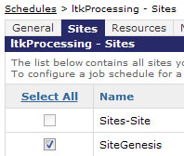

### Pipeline integration

There are several Listrak pipelines that need to be placed inside Demandware pipelines. For each of the modifications below, the standard Demandware SiteGenesis pipelines is shown with a Call Node added that references a Listrak pipeline. These pipelines are:

#### Cart.xml

**Example #1: SiteGenesis included with platform release 12.5 or later**

**Cart-Show** – add ltkSCA directly after CartCalculate call node in the removeProduct action

**Cart-Show** – add ltkSCA directly after the CartCalculate call node in the updateCart action

**Cart-AddProduct** – add ltkSCA directly after Cart-AddItem action

**Cart-EditLineItem** – add ltkSCA directly after Cart-ReplaceLineItemProduct action

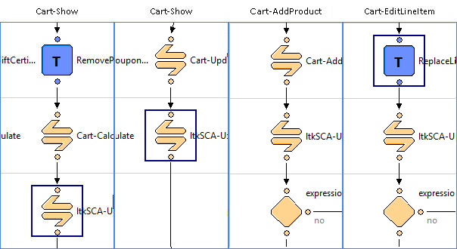

**Example #2: SiteGenesis prior to platform release 12.5**

**Cart-Show** – add ltkSCA directly after CartCalculate call node in the removeProduct action

**Cart-Show** – add ltkSCA directly after the CartCalculate call node in the updateCart action

**Cart-MiniAddProduct** – add ltkSCA directly before checkout/cart/minicart interaction continue node

**Cart-EditLineItem** – add ltkSCA directly after Cart-ReplaceBundleLineItemProducts call node

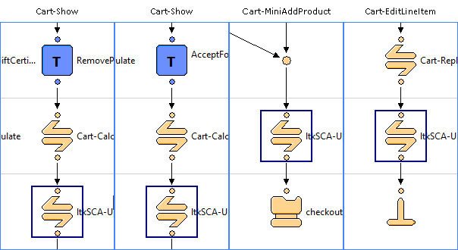

#### COBilling.xml

**COBilling-Start** – add ltkEmailSignup (inline) directly before COSummary-Start jump node

**COBilling-Start** – add ltkSCA directly after ltkEmailSignup

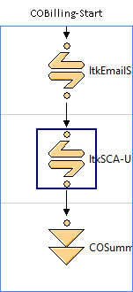

#### COPlaceOrder.xml

**COPlaceOrder-Start** – add ltkConversionTracking directly after SendMail

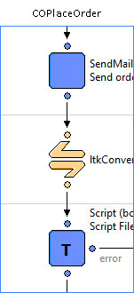

#### Account.xml

**Account-CreateAccount** – add ltkEmailSignup-Inline directly after LoginCustomer

**Account-EditProfile** – add ltkEmailSignup-Inline directly before the final ClearFormElement

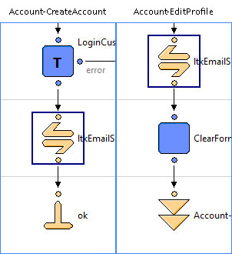

#### OnRequest.xml

**OnRequest-Do –** add ltkActivityTracker-TrackActivity directly before the end node.

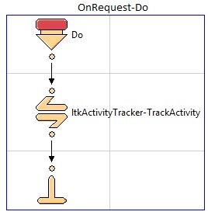

### Basket Preferences

To ensure that baskets are retained for the full cart abandonment email series, we recommend the basket lifetime be set to 7 days and persistent for all customers. This setting can be changed by navigating to **Site Preferences** -> **Baskets** within the BM. Set the following:

* **Basket Persistence** – basket persistent for all customers
* **Basket Lifetime** – 10,080 minutes (7 days)

## Custom Code

**Include template** – a single remote include is necessary to render a JavaScript reference to all pages of the storefront for several purposes: click tracking, SCA email capture and modal acquisition popup. This code is required to be rendered on every page of the storefront. We recommend adding the following line to the bottom of your footer include template, which is typically **templates/default/components/footer/footer.isml**.

<isinclude url=*"${URLUtils.url('ltkInclude-Start')}"*/>

**Email Forms** – if any forms exists that allow customers to subscribe to an email marketing list, the ltkEmailSignup pipeline must be included **on every signup form** to ensure data is sent to Listrak for subscription to a list. Typically the Listrak Professional Services team will assist in defining any forms that should be sending data to Listrak.

Once the pipeline is configured, an ltk_EmailSignup custom object must be created **for every form** to define settings for the pipeline. In the BM, choose a site and select **Custom Objects** -> **Custom Object Editor**. Select **ltk_EmailSignup** from the *Object Type* dropdown and click “New” to create a new definition. Here is an explanation of each setting:

* **Email Signup Name** – a simple description of the signup form (e.g. “Account Creation”)
* **Subscription Code** – a code used to identify these settings in the pipeline (e.g. “accountcreate”)
* **Email Form Field** – the name of the email form input (e.g. “dwfrm_profile_customer_email”)
* **Email Signup Flag Field** – the name of the input for subscription to the list (usually a checkbox). If a value exists for the specified form field when the form is submitted the email will be subscribed to the list. If the “Email Signup Flag Field” is left blank, all submissions will be subscribed.
* **Profile Form Fields** – a list of form input names to send along with email address to Listrak profile fields (e.g. “dwfrm_billing_billingAddress_addressFields_firstName”)
* **Successful Signup Template** – the template file to display upon successful form submission
* **Successful Signup Content Asset** – any content asset associated with the success template (optional)
* **Error Signup Template** – the template file to display if errors are encountered during signup (a very rare occurrence)
* **Error Signup Content Asset** – any content asset associated with the error template (optional)

For forms already integrated with the storefront, the inline version of the ltkEmailSignup pipeline will need to be added to the existing pipeline (just like the COBilling pipeline example above). The standard version will typically only be used if a new form is created for subscription to the email marketing list. The success/error templates must be defined when using standard mode.

Once you have the email signup object saved, all you have to do is add the Subscription Code as a hidden field to your form HTML. Place this code snippet after the <form> tag and replace <code> with the value you just created.

<input type="hidden" name="ltkSubscriptionCode" value="*<code>*" />

If you have any questions about whether you should use the Standard or Inline start-nodes in the ltkEmailSignup pipeline or any other integration questions, please ask your Listrak project manager.

The following are common Demandware email forms which should be integrated:

* **Checkout: Billing Information Page**
* **Checkout: Order Confirmation Page -> Create An Account** Listrak recommends adding an opt-in checkbox to the Create An Account Box on the right of the order confirmation page so that email signups may be captured here.
* **Account Management**

## External Interfaces

The HTTP client is used to send all session and conversion data from the storefront to Listrak. The FTP client is used to upload order history files and customer/product data synchronization purposes. As noted previously, outbound FTP access is required to send data to Listrak and may require opening a support ticket with Demandware. Instructions for submitting a support ticket can be found here:

<https://xchange.demandware.com/docs/DOC-2692>

## Testing

All testing will be outlined by your project manager during the project kickoff meeting with the Listrak Professional Services team.

# Operations, Maintenance

## Data Storage

Data is stored in the custom objects named: ltk_dataObject and ltk_messageObject. As data is sent to Listrak to record session activity and completed purchases, any failed attempts will result in a record in the ltk_dataObject. A scheduled job will periodically attempt to resend these and purge data upon successful transmission.

As errors are trapped by pipelines, they are logged to the ltk_messageObject. This data object is continuously purged by a scheduled job. The messages are utilized to troubleshoot any integration issues that may arise during setup or daily operation.

All files exported for FTP upload to Listrak are stored in a folder created in the import/export directory. These files are deleted upon successful upload to Listrak.

All relevant email subscriber and customer order history data is stored within Listrak databases and may be purged at the merchant’s request.

## Availability

Listrak’s Demandware endpoint infrastructure is configured for maximum availability. In the event requests are not successfully accepted by the endpoint, they will be stored in the custom Listrak data object. Failed requests will be processed by the scheduled job to ensure synchronization is achieved as quickly as possible once availability returns.

Additionally, monitors from Listrak notify developers in the event data is not received from a Deamndware deployment for a specified amount of time, thus alerting us of potential failures in transmission.

## Support

The primary contact person for all defect fixes or improvements is your project manager. If you do not have a project manager, you may contact Listrak support by calling 717-627-4528 ext. 1 or emailing [support@listrak.com](mailto:support@listrak.com).

# User Guide

## Roles, Responsibilities

Once the scheduled jobs are created in the Business Manager, no recurring tasks are required by the merchant.

## Business Manager

**Scheduled Jobs** – all scheduled jobs are imported and do not need any additional configuration changes.

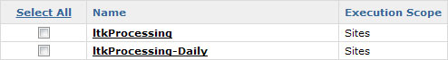

**Custom Objects** – the ltk_emailSignup object is defined and used by the pipeline to determine what variables and data to send to Listrak. Other custom objects are simply data storage objects that are processed by scheduled jobs.

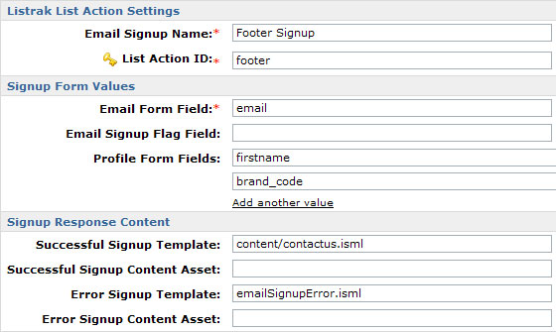

**Custom Preferences** – all settings for the Listrak module are found under the *Site Preferences* -> *Custom Preferences* section. They are labeled **Listrak Store** **Preferences** and include the following settings:

* Listrak Merchant Tracking ID – a unique identifier provided by Listrak during the integration kickoff meeting
* Enable Shopping Cart Abandonment – determines whether shopping cart abandonment data should be sent to Listrak. ***Make sure this setting is selected if you are using a Shopping Cart Abandonment program.***
* Enable Activity Tracking Service – determines whether activity tracking data is sent to Listrak.
* Enable Product Sync – determines whether product data files should be sent to Listrak
* Max # of Recommendations Exported – The maximum number of recommended (related) sku’s to export per product (up to 25). Enter a ‘0’ (zero) to disable exporting recommended products.
* Enable Customer Sync – determines whether customer data files should be sent to Listrak
* Enable Order Sync – determines whether order data files should be sent to Listrak
* Top Level Category Index – Determines the level at which categories should begin to be assigned to your products. For example:  If your category tree is: Root/Online/Men's/Clothing, then if you want Men's to be your starting Category, this value should be set to 3.
* Product Sub-category Levels to export – The number of subcategories you would like to export to Listrak. For example: If you want your category tree to be: /Men's/Clothing/Outerwear/Jackets, and you want to track all the subcategories, you would set this value to 3 which will give you 1 Category (Men’s), and 3 subcategories (Clothing/Outerwear/Jackets)
* Email Capture Fields – the name of any form inputs intended to capture email addresses for cart abandonment
* Email Watermarks – list of watermarks used in email form fields, which is used to prevent submissions of watermarks to Listrak.
* Listrak Activity Tracking Endpoint – URL to send Browse activity, verify “at1.listrakbi.com” is already entered.
* Listrak Tracking Endpoint – URL to send click/conv. data, verify “s1.listrakbi.com” is already entered.
* Listrak Shopping Cart Abandonment Endpoint –URL to send SCA data, verify “sca1.listrakbi.com” is already entered.
* Listrak FTP Host – location of Listrak FTP server, e.g. [*ftp.listrakbi.com*](ftp://ftp.listrakbi.com)
* Listrak FTP Password – defined for each merchant
* Listrak FTP User Name – defined for each merchant
* Use Absolute Product URLs – determines if absolute or relative product URLs should be sent to Listrak. Relative product URLs are recommended. Please contact your Listrak project manager if you believe you may need to use Absolute product URLs
* Use Absolute Image URLs – determines if absolute or relative product URLs are sent to Listrak. If you are utilizing the Demandware content delivery network, you must use Absolute image URLs.
* Product Image View Type – specifies which image URLs will be sent to Listrak. The default behavior is to use the “small” image view type if it is available, and the “large” item view type if “small” is not available. If you use a custom view type you may specify it here.

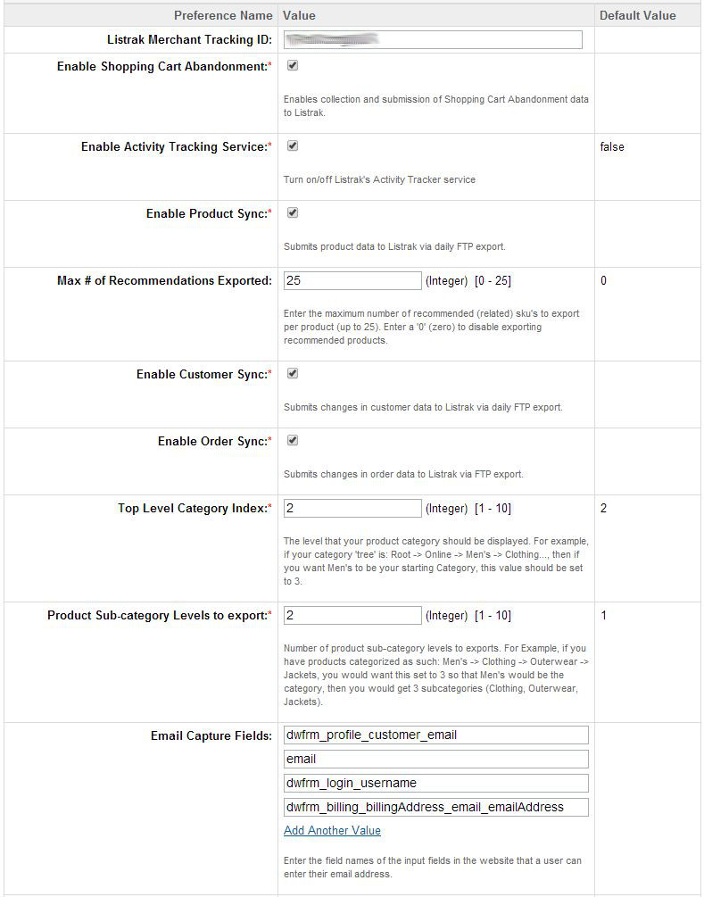

## 

## Storefront Functionality

While most of the cartridge functionality exists behind the scenes, some storefront functionality is exposed, primarily in the form of JavaScript.

**JavaScript Inclusion** – by placing a remote include reference in the footer of the site, Listrak’s JavaScript framework will be loaded on all pages. It will also render JavaScript code to capture email addresses as they are typed for the shopping cart abandonment program, and to track shopper’s browse activity.

**Modal Acquisition** – the popup settings are controlled within Listrak and will display a modal dialog under the defined conditions. The functionality for the popup is provided by the inclusion of JavaScript as mentioned above.

# Known Issues

**Product Sync:** Depending upon user implementation product image urls may not be exported in the correct format. This may require customization of ltkProductSync.ds to correct.

# Release History

|  |  |  |
| --- | --- | --- |
| Version | Date | Changes |
| 1.0.0 | 03-Apr-2012 | Initial release |
| 2.0.0 | 04-08-2014 | Initial 2.0.0 release |